How to prepare a poster for a science conference?
The following is taken from http://guides.nyu.edu/posters:
Posters are widely used in the academic community, and most conferences include poster presentations in their program. Research posters summarize information or research concisely and attractively to help publicize it and generate discussion.
The poster is usually a mixture of a brief text mixed with tables, graphs, pictures, and other presentation formats. At a conference, the researcher stands by the poster display while other participants can come and view the presentation and interact with the author.

What makes a good poster?
- Important information should be readable from about 10 feet away
- Title is short and draws interest
- Word count of about 300 to 800 words
- Text is clear and to the point
- Use of bullets, numbering, and headlines make it easy to read
- Effective use of graphics, color and fonts
- Consistent and clean layout
- Includes acknowledgments, your name and institutional affiliation
Answer these three questions:
- What is the most important/interesting/astounding finding from my research project?
- How can I visually share my research with conference attendees? Should I use charts, graphs, photos, images?
- What kind of information can I convey during my talk that will complement my poster?
To begin: draw your story out on a piece of paper. Like any story, it has a beginning, middle part and end (keep it that simple)! When you think you have your story, check in with your adviser to discuss.
Think about what type of visualizations you need to tell your story. This is how I start:
Story draft:
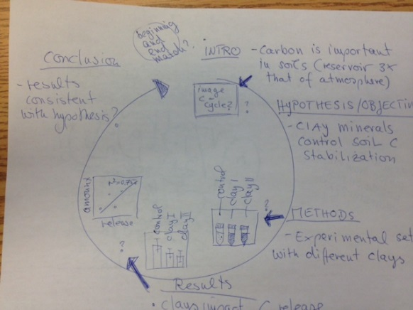

Poster draft:
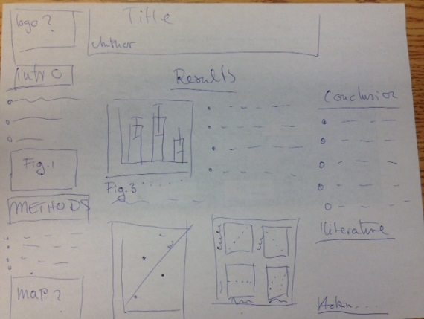
What goes in each section:
(modified from http://colinpurrington.com/tips/poster-design)
Title: Convey the interesting issue, not more that 2 lines. Try to think of 5 keywords that are important in your research and swap these around until you have a titke.
Abstract: Do not include an abstract on a poster. A poster is an abstract of your research.
Introduction: Get your viewer interested in the issue or question while using the absolute minimum of background information and definitions; quickly place your issue in the context of published, primary literature (cite!); then pitch an interesting, novel hypothesis … then you can describe (briefly) the experimental approach that tested your hypothesis. Put a photograph or illustration that communicates some aspect of your research question. [approximately 200 words]
Materials and methods: Briefly describe experimental equipment and procedure, but not with the detail used for a manuscript; use figures and flow charts to illustrate experimental design if possible; include photograph or labeled drawing of organism or setup; mention statistical analyses that were used and how they allowed you to address hypothesis. [approximately 200 words]
Results: I typically use big Figs with Figure captions, nothing else. If your results are preliminary, call the section “preliminary results”.
Conclusions: You want to bring this back to your hypothesis. E.g. “results indicate that organic matter is mostly protected by clay minerals”. Often our research is preliminary, wording like “indicate” or “our results are consistent with” is helpful in these cases.
Literature cited: Include them! Ref list can be very small and abbreviated but has to be there.
Acknowledgments: Thank individuals for specific contributions (equipment donation, statistical advice, laboratory assistance, comments on earlier versions of the poster); mention who has provided funding, e.g. if your funding comes from Hawley Mudge, mention this. If you were partially funde by NSF or EPSCoR include the logo (even if you just used maps or samples that were collected/generated by research funded through them. Also always add UVM logo.
Example of a great poster: http://www.personal.psu.edu/drs18/postershow/
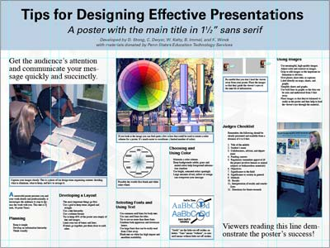
Example of a bad poster: http://betterposters.blogspot.com/2011/04/ 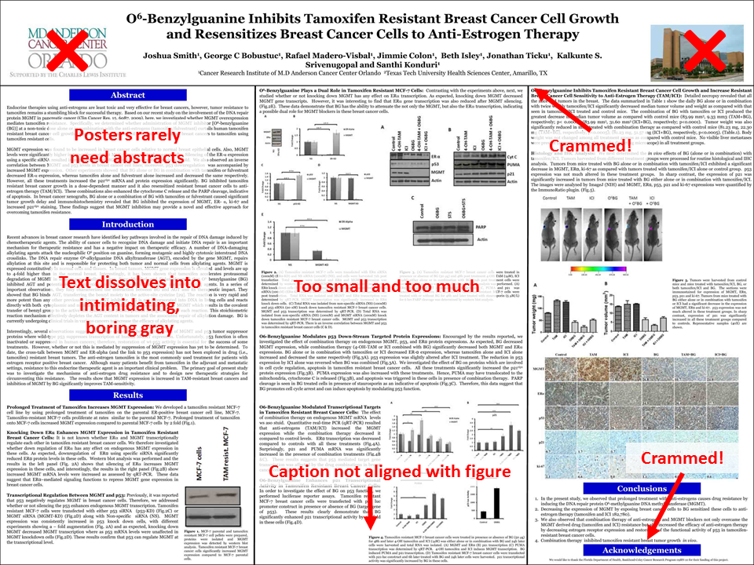
Further information: add your email address so interested audience can contact you
DOs and DON’Ts:
- Aim for 300- 800 words
- Do not add bullets to section headings. The use of a bolded, larger font is sufficient for demarcating sections.
- Use bullet points
- Avoid dark backgrounds, which makes your poster hard to read. Also, designing graphics is harder. It’s better to just use a white background. And you save on ink,
- Complete the entire poster on a single platform. Switching from PC to Mac or Mac to PC invites disaster, sometimes in the form of lost image files or garbled graph axes.
- Give your graphs titles or informative phrases. You wouldn’t do this in a manuscript for a journal, but for posters you want to guide the visitor.
- Increase the font size of your axes labels in plots
- Always write, “data are,” not “data is.” “Data” is a plural noun (“datum” is the singular).
- This is probably obvious … but don’t plagiarize.

