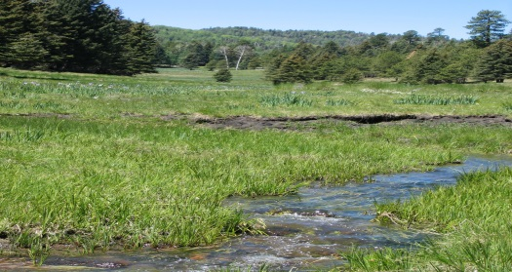
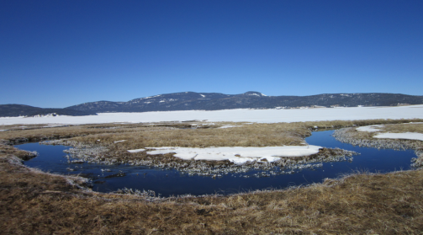
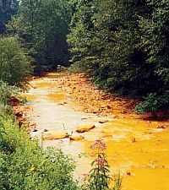
Syllabus

Geochemistry of Natural Waters – GEOL235
Spring Semester 2018
Instructor: Dr. Julia Perdrial, Office: 213C; Tel: (802) 656 0665; Email:Julia.perdrial@uvm.edu
Office hours: M&W 10.30-11:30 and by appointment;
Meeting Time: MWF 9:40-10:30; Credits: 3, Pre-requisites: Chemistry 31, 32.
Welcome!
Welcome to the Aqueous Geochemistry of Natural Waters Course!
We live on the blue planet which is ¾ covered by water and 100% of all living organisms require some form of water to survive. It’s simple, no water- No life. Yet freshwater demand already exceeds supply in certain areas of this planet and water is becoming the “new oil”.
Following the hydrological cycle and the architecture of the Earth surface (i.e. the critical zone) we explore how the geochemistry of water is impacted by processes in the atmosphere, biosphere, pedosphere (soil) all the way down to groundwater, where water interacts with the lithosphere. This is an interdisciplinary course and we will draw from concepts from various fields in Earth and environmental sciences including geology, mineralogy, geochemistry, soil sciences, ecology and hydrology. We will use data from the US Geological Survey and Critical Zone Observatories (CZO) where hands on conceptual and quantitative approaches help you to understand the geochemistry of natural waters in a comprehensive way.
Course Goal #1: Apply the knowledge of solute sources and geochemical reactions (acid-base, redox) to interpret processes controlling the composition of natural waters.
Course Goal #2: Demonstrate the ability to synthesize processes that impact water geochemistry with concept sketches

Course Goal #3: Apply excel spreadsheet analysis of geochemical data to generate interpretable time-series and correlation plots

We will practice with real datasets and formulate and test hypotheses about the source of water constituents and processes that control water chemistry. During class practice times I encourage group work. Take advantage of your peers knowledge and ideas during these times but make sure you have your own learning in mind.
I will assess you learning in 4 principal ways:
- Problem sets: you will be assigned problem sets as homework where you’ll use real data and tools that we practiced in class. This will help me to assess your ability to apply what you learned in class and test you critical thinking skills. I encourage peer-to peer mentoring and it is fine to work in groups on homework but you need to hand in the homework separately. Take responsibility of your own learning and make sure that this group work enables you to do it by yourself - you will need it for the exams.
- Exams: you will have two exams where I will test your knowledge, comprehension and critical thinking skills.
- Group work: I will assess your contribution in class during exercises, group work etc. Please note that absence from class can negatively influence your grade.
- Presentation: I will assess your science communication skills (paper presentation).
Grading:
The different learning assessments will contribute to the overall grade as follows:
Problem sets 40%
Exams 30%
In class exercises and contribution, group work 15%
Paper presentation 15%

These are the assessment rubrics for quizzes, exams and problem sets:

 | Quizzes and Problem sets |  | Concept Sketches
Level of Achievement | General Approach | Comprehension | Content and Presentation
Exemplary  100% of points | - Addresses the question.  - States a relevant, justifiable answer.  - Presents arguments in a logical order. | - Demonstrates an accurate and complete understanding of the question.  - Backs conclusions with data and warrants.  - Uses ideas, examples and/or arguments that support the answer. | - Essential concepts all shown;  - important relationships correctly portrayed; no conceptual errors or evidence of misunderstanding  - Sketch detailed and clearly drawn and labeled
Adequate  75% of points | - Does not address the question explicitly, although does so tangentially.  - States a relevant and justifiable answer.  - Presents arguments in a logical order. | - Demonstrates accurate but only adequate understanding of question because does not back conclusions with warrants and data.  - Uses idea to support the answer.  - Less thorough than above | - Most concepts and relationships shown correctly;  - some aspects left out; minor conceptual errors or misunderstandings  - Sketch lacks some detail or not clearly drawn or labeled
Needs Improvement  25-50% of points | - Does not address the question.  - States no relevant answers.  - Indicates misconceptions.  - Is not clearly or logically organized. | - Does not demonstrate accurate understanding of the question.  - Does not provide evidence to support their answer to the question. | - Essential concepts left out; relationships not correctly portrayed;  - major conceptual errors or misunderstandings  - Sketch lacks detail or is illegible; difficult to interpret
No Answer
(0 pts)

Teaching and Learning Style: Students learning style and instructors teaching style do not always match but there are ways to help each other. A good start is to assess your own learning style and to find out what you can do to support your own learning. Please take the “Index of Learning Styles Questionnaire” following this link:
http://www.engr.ncsu.edu/learningstyles/ilsweb.html
The results are for yourself only, but this very simple test will help you to better understand your learning (and probably my teaching).

Rules:
- Please turn in your homework problem sets in time; it will decrease your grade by 10% per day if you turn it in late.
- If you are sick and have to miss exams contact me ASAP.
- Please mute cell phones during class and don’t text or email.
- Adhere to the Code of Academic Integrity (no plagiarism, fabrication, collusion, and cheating). Deliberate offense against the code will be forwarded to the Center for Student Ethics and Standards (see http://www.uvm.edu/~uvmppg/ppg/student/acadintegrity.pdf for more information).
Student learning accommodations:
- Any student with a documented disability interested in utilizing accommodations should contact ACCESS, the office of Disability Services on campus.
ACCESS works with you to create reasonable and appropriate accommodations via an accommodation letter to their professors as early as possible each semester.
Contact ACCESS: A170 Living/Learning Center - 802-656-7753 - access@uvm.edu.
Further Reading: there is no required book for this course, we will be mostly reading peer reviewed papers which will be on blackboard. However, the following books may be helpful if you struggle with some concepts in chemistry.
“ Environmental and Low temperature Geochemistry” by Pete Ryan;
“Geochemistry of Natural Waters” by James I. Drever;
“Global Environment: Water, Air and Geochemical Cycles” by Berner and Berner;
“Soil and Water Chemistry, an Integrative Approach” by Essington.

Schedule (subject to changes):
