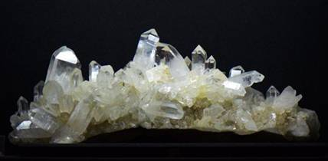
H

Earth Materials – GEOL 110
Spring Semester 2018

Instructor: Dr. Julia Perdrial, Office: 213C; Tel: (802) 656 0665;
Email:Julia.perdrial@uvm.edu
Teaching Assistant: Cheyne Aiken (claiken@uvm.edu).
Office hours: MW 10:30-11:30 and by appointment;
Meeting Time: Lecture TR 1:15-2:30; Lab either T or R 2:50-5:40
Credits: 4
Pre/co-requisites: GEOL 001, GEOL 005 or GEOL 055.
Book: Earth Materials: Introduction to Mineralogy and Petrology, Cornelius Klein and Anthony Philpotts, Cambridge University Press
Welcome to Earth Materials!
Human history is closely coupled to Earth materials. For example early cultural evolution is classified based on Earth Materials (Stone Age, Bronze Age, Iron Age) and we would not have buildings, toothpaste or I-phones without minerals and assemblages of minerals (rocks). The exploration and use of Earth Materials, especially since the industrial revolution, confronts us with important issues of social, environmental and economic sustainability. But Earth materials go much further back in time than the ~ 2 million years of human history: they can tell us about Earth processes over the last billion years and provide us with a window into the fascination history of our universe.
Whether we want to explore the Earth’s history of sea-level change, rise and fall of mountain ranges, or the occurrence of gold, we need to be able to identify minerals and rocks and place them into the local and regional context. In this course we will therefore introduce basic concepts of mineralogy (chemistry, structure and properties of minerals) and petrology (composition, structure, origin and distribution of rocks) in lab and lecture.

Course Goals: at the end of this course you will be able to
1) identify samples of the common rock-forming minerals in hand samples and thin sections of common rocks.
2) synthesize mineralogical data (visual inspection, petrographic microscopy) to make inferences on the (plate tectonic) setting producing selected rocks.
3) Combine writing and visualizations to communicate these syntheses to science and non-science audiences.
4) critically evaluate how the use of specific Earth materials impacts social, environmental and economic sustainability.
Lectures:
We will use lecture class meeting times to explore the necessary background across time and spatial scales ranging from molecular scale structures to plate tectonic settings and the history of our solar system to challenges of the Anthropocene. Using group work, discussions and paper presentation, everybody will be engaged during class meeting times. Please get a copy of “Earth Materials” from Klein and Philpotts to follow along.
We will also use lecture meetings for a paper presentation from each of you. For this you will be asked to choose a scientific paper dealing with Earth materials and their importance for human life (as a power point) to the class. Your presentation will be evaluated by me and the TA. We’ll have a dry run so that you’ll know what to expect and can prepare accordingly.
Labs:
You will spend most of the lab meeting times in the petrology lab working with rocks and minerals but we will also use the computer lab occasionally. You will receive training in the identification minerals and rocks in hand specimen and thin sections. You will also work towards structured, easy to read writing using language appropriate for different audience. Peer feedback will be one of the tools we will use to improve your writing skills. Make it to the labs, it will be hard to make up for missed sessions and more that 2 missed labs result in the failure of the course!

Transferable Skills: During this course you will also learn the following skills that are helpful outside the scope of this course:
You will train your 3-D visualization
You will learn how to synthesize observations and data into a process interpretation
You will practice comprehensive, concise scientific writing
You will learn to solicit/use feedback to improve your own performance

Learning assessment: I will assess your learning in the following principle ways:

- RoCKS Doc = 20%: You will compile a “Record of Core Knowledge and Skills (RoCKS)” document (RoCKS-Doc) that you will fill with key knowledge (factual) and skill contents. The general quality of the RoCKS Doc will be assessed as described in the appendix (appendix A).

- Writing assignments = 30%: You will integrate two more detailed writing assignments into your RoCKS Doc. For these you will synthesize you knowledge (lecture) and skills (labs) to provide a fact sheet on rocks and minerals of your choice (2*15% of the grade). Detailed instructions for the writing assignments will be given well in advance of the deadlines that typically are in week 5 and 10. Note that this is also the time where we will review the general quality of your RoCKS DOC (Appendix B and C).

- Final Poster = 15%: We will have a mini conference at the end of the semester (this is you final exam). In groups of 3-4 you will present a final group poster on selected aspects of Earth materials sustainability. The poster will be your 3rd writing assignment(Appendix D).

- Quizzes in Lab and Lecture = 25%: Quizzes on reading and material covered in lab and lecture will test your preparation throughout the semester. We will provide you with a study guide before each quiz.

- Oral presentation = 10%: Oral presentation of a paper of your choice in groups of 2 (20 minutes and discussion) on the sustainability of Earth Materials.

Teaching and Learning Style:
It’s always helpful to know about your own learning style and know what you can do to support your own learning. Please take the “Index of Learning Styles Questionnaire” following this link:
http://www.engr.ncsu.edu/learningstyles/ilsweb.html
The results are for yourself only, but this very simple test will help you to better understand your learning (and probably my teaching).

Rules:
- Make it to class: you can miss class twice, more missed classes will impact you grade. If you miss classes more than 6 times you may fail the class.
- If you miss more than 2 labs you will fail the course.
- Please turn in your assignments in time; I will decrease your grade by 10% per late day.
- Please complete your reading, we will have graded quizzes in lab and lecture.
- Please mute cell phones during class and don’t text.
- Adhere to the Code of Academic Integrity (no plagiarism, fabrication, collusion, and cheating). Deliberate offense against the code will be forwarded to the Center for Student Ethics and Standards (see http://www.uvm.edu/~uvmppg/ppg/student/acadintegrity.pdf for more information).
Student learning accommodations: Any student with a documented disability interested in utilizing accommodations should contact ACCESS, the office of Disability Services on campus. ACCESS works with you to create reasonable and appropriate accommodations via an accommodation letter to their professors as early as possible each semester.
Contact ACCESS: A170 Living/Learning Center - 802-656-7753 - access@uvm.edu.
Schedule (subject to changes):
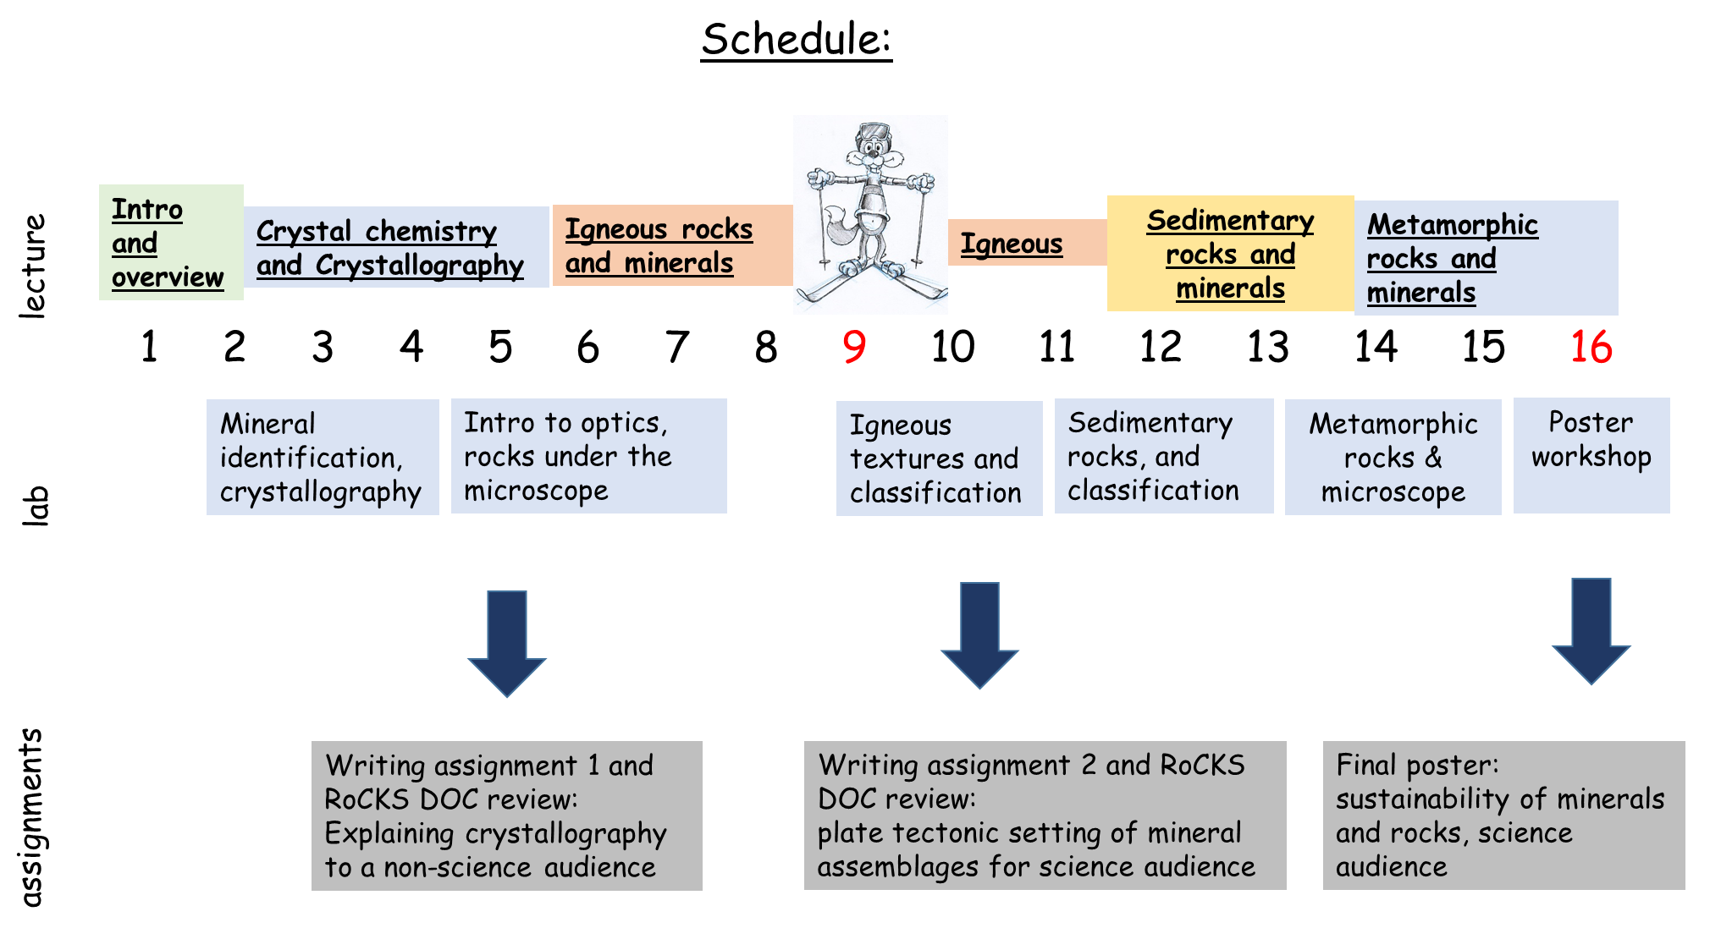

Week 1:
Introduction to Earth Materials (reading Chapter 1)
(No lab)
Week 2:
Introduction to Earth Materials (reading Chapter 2)
Lab: Mineral identification (reading Chapter 4)
Week 3:
Crystal structures (reading Chapter 4)
Lab: Crystal maker
Week 4:
Crystallography (reading chapter 5)
Lab: Crystallography
Week 5:
How do igneous rocks form? (Chapter 8)
Lab: optics, igneous rocks and minerals under the microscope (Chapter 6)
RoCKS Doc including writing assignment 1 due
Week 6:
Occurrence, classification and setting for igneous rocks (Chapter 9)
Lab: optics, igneous rocks and minerals under the microscope (Chapter 6)
Week 7+8:
Occurrence, classification and setting for igneous rocks (Chapter 9)
Lab: optics, igneous rocks and minerals under the microscope (Chapter 6)

Week 9: Spring break

Week 10:
Formation of Sedimentary rocks (Chapter 11)
Lab: sedimentary rocks
Week 11-12:
Occurrence, classification and setting of sedimentary rocks (Chapter 12)
Lab: sedimentary rocks
Week 13:
Metamorphic rocks and minerals (Chapter 14)
Lab: metamorphic rocks under the microscope
RoCKS Doc including writing assignment 2 due
Week 14:
Metamorphic rocks and minerals (Chapter 14)
Lab: metamorphic rocks under the microscope
Week 15:
Workshopping the final Poster
Lab: open lab

APPENDIX A:
Instructions: Building a Record of Core Knowledge and Skills (RoCKS) Document in Geology:
We will be expecting you to recall information and skills from any geology course you’ve already taken and apply it to subsequent courses. To help you with this we use a knowledge base that will increase with each course: we call it Record of Core Knowledge and Skills (or RoCKS Document).
What:
The RoCKS document (RoCKS-Doc) is a document for each class filled with key knowledge (factual) and skill contents of each of your geology courses beginning with GEOL 062 and GEOL 110.
Faculty in each course will give you a blank RoCKS-doc containing their course’s basic concepts. You will be asked to use this material, supplement it with your own notes and/or visualizations and synthesize several concepts (see example below).
GEOL 110 puts emphasis on synthesizing information rather than simply compiling it, therefore your RoCKS-Doc will already have content.
The skills section in contrast needs to be completed by you. We do this because want to create awareness for your developing disciplinary and transferable skills and we want you to be able to describe them.
How:
- You will receive the blank RoCKS-Doc for Earth Materials in several parts via Black Board. This blank document will contain Figures and general themes and questions, but no explanations.
- As we go along, you will complement your RoCKS-Doc with answers to these questions and we will review them twice. This will help you keep track and can also serve as a study guide for quizzes.
- The RoCKS-Doc content can also help you with your writing assignments. Detailed information on these writing assignments will be available several weeks before they are due but you can take a look at the ones from last year (below) to get an idea. Its ok to use Figures from RoCKS-Doc as long as the original source (not RoCKS-Doc) is cited correctly.
- The skill section has not content. We ask you to keep track and add them to your RoCKS-Doc as you go along.

Format:
- The RoCKS-Doc is structured into chapters (courses) and sections (knowledge, specific skills and transferable skills):
Chapter 1: Earth History (GEOL062)
1.1. Knowledge
1.2. Specific skills
1.3. Transferable skills
Chapter 2: Earth Materials (GEOL 110)
2.1. Knowledge
2.2. Specific skills
2.3. Transferable skills
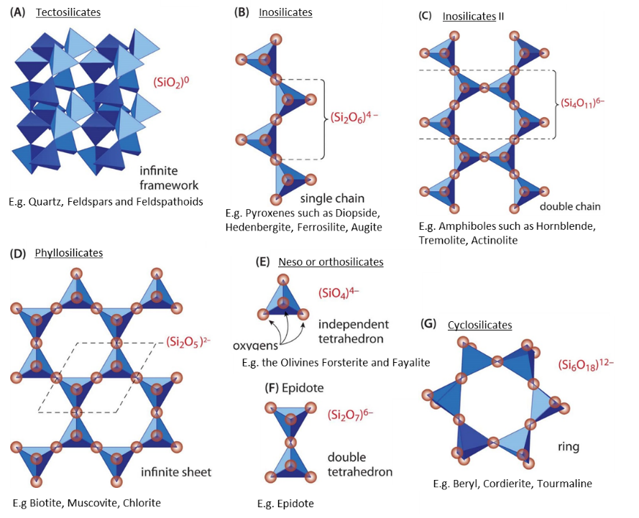
Example: You will have this figure in your blank RoCKS-Doc. The question I would like you to answer using this Figure is “how does the structural formula of silicates reflect their structure (e.g. the silicate class)?”. You will need to combine reading, your own notes and your experience from exercises in class to accurately and comprehensively answer this question. You can also add another figure but make sure you cite the source correctly if you did not make the figure yourself.
Figure modified from Klein and Philpotts (2013). Earth Materials: An Introduction to Mineralogy and Petrology, Cambridge Press.
Assessment:
Your RoCKS-Doc will be assessed during and at the end of the semester. We will assess how relevant, accurate and insightful your answers to these questions are.
The assessment of your RoCKS-Doc is based on the following rubric:
Exceed expectations (A): the content represents a complete and detailed summary of the contents of the course. Answers are complete, insightful and audience appropriate (GEOL 110 students). Additional figures are clear, original or cited correctly.
Meets expectations (B-C): the content, although it includes the important concepts, could include more detailed summaries. Additional figures and tables are of medium quality and/or not cited correctly.
Falls short (D): the content is missing important concepts or does not correctly summarize it.

APPENDIX B Writing assignment I (NOTE: these are examples from last year, your assignment may change a little).

GEOL 110 Mineral fact sheet due 02/23/17 @ 5PM by email
- This “mineral fact sheet” is to be included as part of your RoCKS Doc knowledge section.
- Note, that the RoCKS Doc content will be reviewed at the same time. Consult the information on BB for a complete list of content to include.
- Please read the entire assignment before beginning.

ASSIGNMENT:
- Design an information and fact sheet on the composition and structure of a mineral of your choice. Your target audience are first year students (e.g. a GEOL001 student). This means you should use (but explain) scientific vocabulary.
- The objective of your flyer is to inform first year students i) how the molecular scale properties (composition and structure) determine physical mineral properties and ii) how this helps mineral identification.
- Include typical characteristics of your mineral such as hardness, cleavage, luster or habit.
- Use at least two types of visualizations including a picture of the mineral and a structure you designed in Crystal Maker (this might limit what mineral you want to showcase).
- Use your writing and visualizations to support each other.
- Use information from reliable resources, e.g. text books from the library and cite them.

Foundational writing Goals – Rhetorical Discernment (who is the audience?) and Information Literacy (where do I get my reliable information?)

Format:
- Font: equivalent to times new roman 11 for bulk text, font can be larger for headlines.
- Use figure numbers, cite them in the text and use figure captions.
- Minimum 2 types of figures.
- Integrate this into your RoCKS Doc.

Information sources and citation format:
Perform library research for peer reviewed publications and/or cite reliable documents such as standard text books (e.g. Manual of Mineralogy, Klein and Hurlbut). If you use visualizations from the internet make sure you find the original source and cite it. You can also cite web pages ONLY if they are the original source. In this case copy paste the url into the text in brackets but please keep in mind that internet sources are not typically considered reliable information sources! (Please see grading rubrics as well).

These examples are important guidelines:
1) You use a figure from an article or book: describe the figure and add the author names and the year of publication in brackets after your description (e.g. Klein & Hurlbut, 1985). At the end of the RoCKS Doc you will add the full reference:
Klein, C. and Hurlbut, C. (1985) Manual of Mineralogy. 20th edition. John Wiley and Sons. 596 pages.
2) You want to back up a statement with a citation: E.g. “This mineral is, with a relative hardness of 7 on the Moh’s scale, one of the hardest rock forming minerals (Klein & Hurlbut, 1985).” Again at the end of the RoCKS Doc you will add the full references:
Klein, C. and Hurlbut, C. (1985) Manual of Mineralogy. 20th edition. John Wiley and Sons. 596 pages.
3) You want to cite a web page: you should only cite a webpage if you cannot get the same information from a more reliable source. Just add the abbreviated url in brackets after your statement of under a figure (http://webmineral.com). There is no need to add this information at the end of the RoCKS Doc under “references” again.

In preparation of this assignment consider the following:
- The objective of your flyer is to inform first year students i) how the molecular scale properties (composition and structure) determine physical mineral properties and ii) how this helps mineral identification.
- In order to address this objective, what needs to be introduced? What vocabulary should be used and explained?
- How can you best structure the fact sheet?
- How can your outline help to bring information across and be interesting to a first year student?
- Where do you get your information?
- What type of visualizations do you want to include?

Grading:
- Visual (use plots, pictures and/or concepts that support the objective of the fact sheet)
- Writing (use writing that supports visual information, is audience appropriate, flows well and is structured. E.g. molecular scale: mineral composition and structure, macro scale properties). Also, is the objective addressed?
- Information and sources (focus on correctness and use of reliable information sources)

RUBRICS:
Level of Achievement | Writing and creativity | Visual | Information and sources
Exemplary  100% of points | - Writing is throughout audience appropriate  - Writing flows well to support the content and visualization  - Fact sheet is well structured  - Ideas and content choices show creative ingenuity and are convincing and address the objective | - Two types of visualizations (including crystal maker structure) are shown that support the objective of the fact sheet  - Visual representations are appealing, clear, legible, and (for plots) labelled | - Information is correct and dense (complete) including important physical properties, crystal system etc.  - Reliable sources are used and correctly cited
Adequate  75% of points | - Writing is mostly audience appropriate  - Writing flows mostly well to support the content and/or visualization  - Fact sheet is mostly structured  - Some ideas and content choices show creativity and some are convincing and address the objective | - 1 type of visualizations are shown or choices of figs does not support the objective of the fact sheet  - Visual representations are appropriate but may lack in appeal, clarity and or lack labels | - Information is mostly correct and complete but some important characteristics may have been felt out.  - Information sources are cited but may not be the most reliable (e.g. Wikipedia).
Needs Improvement  25-50% of points | - Writing is not audience appropriate  - writing is bumpy and incoherent, does not connect to content or visualization  - Fact sheet lacks clear structure  - Ideas and content are not convincing, objective not addressed | - 1 or less visualization is shown  - Visualization does not support the fact sheet and lack in appeal, clarity and or lack labels | - Information is incorrect and/or very shallow  - No information sources are described and cited or all are unreliable
No Answer
(0 pts)
Plagiarism: is a serious offense intentional or not. It is NOT ok to simply copy-paste text from web pages or similar. You are expected to abide by the Code of Academic Integrity. If you are found to violate this policy, you will be reported to the Center for Student Ethics and Standards. The outcome will depend upon the degree of plagiarism.

APPENDIX C writing assignment II
GEOL 110, Assignment II: Igneous Rocks in their tectonic setting
Due: 04/11/2016 via email to Cheyne
- Design a two page information and fact sheet on an igneous rock of your choice.
- This assignment should be integrated into your RoCKS Doc. You can either send it along with you RoCKS Doc or send separately and integrate later.
- include mineral content (description in hand specimen and thin section) and its tectonic setting.
- This writing assignment targets next year’s Earth Materials Students, which means you should use scientific vocabulary and can assume your audience begins to know this vocabulary but you should explain concepts.
- The objective of your flyer is to inform GEOL110 students how content and texture of an igneous rock of your choice can help to identify the plate tectonic setting of rock formation.
- Include a description of your hand specimen as well as a description of accompanying thin section.
- Use at least 4 types of visualizations including i) a labeled picture of your thin section in plane polarized light, ii) cross polarized light, iii) hand specimen and iv) a sketch of the tectonic setting (you can either draw one or take it from the web/ book if cited correctly).
- Use your writing and visualizations to support each other.
- Research your rock by using reliable resources, e.g. text books from the library, USGS reports etc.
Foundational writing Goals – Rhetorical Discernment (what is the audience), Information Literacy (where do I get my reliable information?).
Format:
- 2 pages in word
- Font: equivalent to times new roman 11-12 for bulk text
- font can be larger for headlines
- Minimum 3 figures including a sketch, and pictures of thin sections.
Information sources and citation format (Like for the previous assignment):
Perform library research for peer reviewed publications and/or cite reliable documents such as standard text books (e.g. Manual of Mineralogy, Klein and Hurlbut). If you use visualizations from the internet make sure you find the original source and cite it. You can also cite web pages if they are the original source. In this case copy paste the url into the text in brackets.
Examples:
1) You use a figure from an article or book: describe the figure and add the author names and the year of publication in brackets after your description (e.g. Klein & Hurlbut, 1985). At the end of the flyer (small front 8-10) you will add the full reference:
Klein, C. and Hurlbut, C. (1985) Manual of Mineralogy. 20th edition. John Wiley and Sons. 596 pages.
2) You want to back up a statement with a citation: E.g. “This mineral is, with a relative hardness of 7 on the Moh’s scale, one of the hardest rock forming minerals (Klein & Hurlbut, 1985).” Again at the end of the flyer you will add the full references:
Klein, C. and Hurlbut, C. (1985) Manual of Mineralogy. 20th edition. John Wiley and Sons. 596 pages.
3) You want to cite a web page: you should only cite a webpage if you cannot get the same information from a more reliable source. Just add the abbreviated url in brackets after your statement of under a figure (http://webmineral.com). There is no need to add this information at the end of the poster under “references” again.

In preparation of this assignment consider the following questions:
- Which rock of the collection do you want to feature? You can use any of the rocks we used in class. Ask Cheyne for input and access to the hand specimens and thin sections.
- Stick with the objective: if you are unsure whether you should include certain information or figure check if it serves the objective.
- In order to address this objective, what needs to be introduced? What vocabulary should be used, which concepts explained?
- How can you best structure the flyer? Pay attention to this and test the structure with a reverse outline.
- Where do you get your information?
- What type of visualizations do you want to include?
Grading (see rubric and self check):
- Objective is addressed
- Visual (plots, pictures and/or concepts support the objective of the flyer)
- Writing (writing supports visual information, is audience appropriate, flows well and is structured).
- Information and sources (correctness and use of reliable information sources)

RUBRICS:
Level of Achievement | Writing and creativity | Visual | Information and sources
Exemplary  100% of points | - Writing is throughout audience appropriate  - Writing flows well to support the content and visualization  - Flyer is well structured  - Ideas and content choices show creative ingenuity and are convincing | - Two types of visualizations are shown that support the objective of the info flyer  - Visual representations are appealing, clear, legible, and (for plots) labelled | - Information is correct and dense (complete) including mineral descriptions, rock classification etc.  - Reliable sources are used and correctly cited
Adequate  75% of points | - Writing is mostly audience appropriate  - Writing flows mostly well to support the content and/or visualization  - Flyer is mostly structured  - Some ideas and content choices show creativity and some are convincing | - 1 type of visualizations are shown or choices of figs does not support the objective of the info flyer  - Visual representations are appropriate but may lack in appeal, clarity and or lack labels | - Information is mostly correct and complete but some important characteristics may have been felt out.  - Information sources are cited but may not be the most reliable (e.g. Wikipedia vs. peer reviewed article or textbook).
Needs Improvement  25-50% of points | - Writing is not audience appropriate  - writing is bumpy and incoherent, does not connect to content or visualization  - flyer lacks clear structure  - Ideas and content are not convincing | - 1 or less visualization is shown  - Visualization does not support the flyer and lack in appeal, clarity and or lack labels | - Information is incorrect and/or very shallow  - No information sources are described and cited or all are unreliable
No Answer
(0 pts)

Self-check: you can do this yourself and/or have a friend help you. Go through the list, if the answer to all questions is “yes” you are in good shape.
Writing
Is the objective explicitly addressed?
Is the writing throughout audience appropriate (GEOL110 students)?
Does writing flow well?
Is factsheet structured?
Are ideas and content choices creative and convincing?
Visualizations
Are 4 types of visualizations shown?
Is the tectonic setting sketch appropriate?
Do Figs and writing support each other (e.g. are referred to)?
Are Fig. numbers used and referred to in the text?
Is the visual representation clear, legible, and labelled (including the axes).
Information and sources
Information is correct and dense (complete), showing and explaining important physical properties (hardness, luster, cleavage, habit etc)?
Are reliable info sources used?
Are sources correctly cited including the crystal maker database?

Plagiarism: is a serious offense intentional or not. It is NOT ok to simply copy-paste text from web pages or similar. You are expected to abide by the Code of Academic Integrity. If you are found to violate this policy, you will be reported to the Center for Student Ethics and Standards. The outcome will depend upon the degree of plagiarism.

APPENDIX D writing assignment III
GEOL 110 Assignment III: Group poster on a topic of choice linked to Earth Materials and sustainability
Dates and Deadlines:
05/02 before 3pm (Tuesday) last possible time for printing (send the poster to Cheyne as PDF).
05/04 (Thursday) @ 1:15 – 2:30 in room 219: Final exam mini conference. You will present your poster to me and members of the geology department. Setup is 1:15-1:30. Conference opens to public @ 1:30-2:30.
General info:
- Design a poster as a group (3-4) that links sustainability and Earth materials.
- Your objective is to showcase Earth materials that have important implications for economic, social and/or environmental sustainability and to link macro and molecular scale properties to the tectonic setting to these sustainability aspects. For example: what is asbestos, how does it form, what is a typical setting and what are its implication for economic and social (health) sustainability.
- Your target audience are members of the geology department (this could be faculty, staff and students). This means you should use scientific language, scientific in text citation (see examples below) and you can assume basic scientific understanding.
- Use tools we explored for structured writing such as reverse outlines.
- Choose layout, text and visualizations (pictures, graphs, concepts) that support the objective of your poster and help to tell the story in a logical way.
- Your writing has to be objective and audience-appropriate
- CHECK the rubrics at the end of the assignment!

Foundational writing Goals – Rhetorical Discernment (what is the audience), Information Literacy (where do I get my reliable information?).
How this assignment relates to the overall course goals:
Goal #1: Identify samples of the common rock-forming minerals in hand samples and thin sections.
This assignment: you describe your Earth material macroscopically
Goal #2: Link molecular scale properties of Earth materials to their physical and chemical properties that help with their identification. This assignment: you give molecular scale information (e.g. needle-like habit of asbestiform minerals).
Goal#3: synthesize mineralogical data (visual inspection, petrographic microscopy) to make inferences on the (plate tectonic) setting producing selected rocks. This assignment: you give information about the setting (e.g. hydrothermal alteration).
Goal #4: Critically evaluate how the use of specific Earth materials impacts social, environmental and economic sustainability.

Format: Use the template (on BB) for this assignment and adapt it as you see fit (for reference: total word count on the posters should not exceed 600).
Information sources and citation format (Like for the previous assignment):
Perform library research for peer reviewed publications and/or cite reliable documents such as standard text books (e.g. Manual of Mineralogy, Klein and Hurlbut, 1985). If you use visualizations from the internet make sure you find the original source and cite it. You can also cite web pages if they are the original source. In this case copy paste the url into the text in brackets.
Examples:
1) You use a figure from an article or book: describe the figure and add the author names and the year of publication in brackets after your description (e.g. Klein & Hurlbut, 1985). At the end of the flyer (small front 8-10) you will add the full reference:
Klein, C. and Hurlbut, C. (1985) Manual of Mineralogy. 20th edition. John Wiley and Sons. 596 pages.
2) You want to back up a statement with a citation: E.g. “This mineral is, with a relative hardness of 7 on the Moh’s scale, one of the hardest rock forming minerals (Klein & Hurlbut, 1985).” Again at the end of the flyer you will add the full references:
Klein, C. and Hurlbut, C. (1985) Manual of Mineralogy. 20th edition. John Wiley and Sons. 596 pages.
3) You want to cite a web page: you should only cite a webpage if you cannot get the same information from a more reliable source. Just add the abbreviated url in brackets after your statement of under a figure (http://webmineral.com). There is no need to add this information at the end of the poster under “references” again.

In preparation of this assignment consider the following questions:
- What is the objective?
- What is the story of your poster?
- What needs to be introduced? E.g. why is this theme important?
- What is the main body of your poster? What type of information do you want to include?
- How can your outline/layout help to tell your story?
- Where do you get your information from?
- What type of visualizations do you want to include?
- How can you make the link to sustainability?
Plagiarism: is a serious offense intentional or not. Either way you are expected to abide by the Code of Academic Integrity. If you are found to violate this policy, you will be reported to the Center for Student Ethics and Standards. The outcome will depend upon the degree of plagiarism.

These are the criteria we are going to evaluate:
IDEA:Poster addresses the Earth materials and sustainability theme in a creative way
CONTENT:Content is/seems accurate and complete
OBJECTIVE: Objective is met (showcase Earth materials that have important implications for economic, social and/or environmental sustainability and to link macro and molecular scale properties to the tectonic setting to these sustainability aspects)
LAYOUT:Poster is clearly structured, easy to follow and pleasing to the eye
VISUALS: Figures are well chosen to support the message (objective) of the poster
WRITING: Writing supports visualizations and the objective of the poster, free of spelling errors and flows well, using correct citations.
PRESENTATION:Presentation flows well, key points are covered
DISCUSSION:Presenters invites questions and answers knowledgeably

