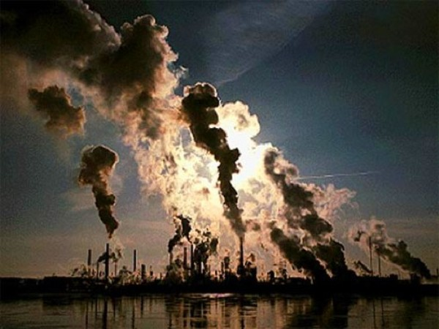
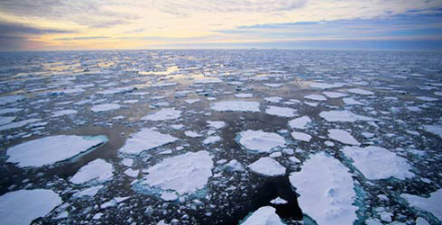
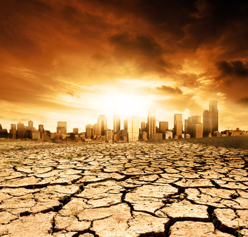
Syllabus

Climate change and sustainability – GEOL095
Fall Semester 2018/2019
Instructor: Dr. Julia Perdrial, Office: 213C; Tel: (802) 656 0665; Email:Julia.perdrial@uvm.edu
Office hours: M&W 10.45-11:45 and by appointment;
Meeting Time: MWF 9:40-10:30; Credits: 3
Welcome to the TAP class on climate change and sustainability!
This course: sustainability is emerging as a central theme in the Anthropocene, whether it be from the perspective of natural science, economics, or society. Via lectures, debates, group work, and shared writing, this course will explore different dimensions of sustainability and their link to one of the most important environmental issues, global climate change.
This is a course on information literacy and writing: both sustainability and global climate change are topics that are broadly discussed, but where does the information, fueling these discussions, actually come from and how reliable is it? As part of this course we will explore and evaluate reliability and intention of different information sources on these controversially discussed topics.
In sciences, writing is used in a variety of ways, e.g. to develop ideas, structure thoughts, describe visual displays of data, interpret and discuss scientific findings. Because science writing is often linked to data and its visualization (maps, graphs, plots), we will work with data, make graphs and describe and interpret them. As a final assignment you will prepare a poster for a mini conference on sustainability and global climate change that you will present as a group.
This is a science communication course: scientists are notoriously bad at communicating science, which is one of the reasons why the general public sometimes think scientists disagree on climate change. We will therefore work on science communication using a variety of hands on improvisation exercises. You will be able to showcase your communication skills in a brief group video on climate change.
This is a sustainability course: in the context of the emerging challenges of the Anthropocene UVM has a vision for educating all of its students to understand and contribute to the sustainability of human society. We recognize that the pursuit of ecological, social, and economic vitality must come with the understanding that the needs of the present be met without compromising the ability of future generations to meet their own needs. Coursework and experiences in sustainability are therefore meant to widen social, historical, and cultural perspectives and strengthen students' ability to negotiate multiple values that routinely come into play when planning for sustainability at the local, regional or global scales (text modified from https://www.uvm.edu/faculty_senate/faculty_resources_sustainability_designation). The sustainability learning outcomes are therefore an integral part of this course (see goals and outcomes).
Goals and outcomes:
Writing goals:
- At the end of this course you will be able to evaluate intention and reliability of information sources on global climate change from multiple sources.
- You will be able to display the relationship between global climate change and sustainability concepts visually and give a written description and interpretation of data.
Communication goals:
- You will be able to define a communication goal related to climate change targeted to a non-science audience.
Sustainability learning outcome:
- At the end of this course you will be able to have an informed conversation about the multiple dimensions of sustainability.
- You will be able to evaluate sustainability aspects of climate change using a data-based approach to integrate economic, ecological, and social aspects.
- You will continue to think critically about how climate change impacts sustainability across a diversity of cultural values and across multiple scales of relevance from local to global.
- Lastly, you will begin to reflect on how sustainability impacts you lives and how your actions impact sustainability.
Make it to class: This is a non-traditional course since I’ll be spending comparatively less time lecturing but you’ll be spending relatively more time discussing and working with texts and data during class meeting times. Because of this structure it is important that you do not miss class since it will be difficult to catch up by yourself.
Group work: During class practice times I encourage group work. Take advantage of your peer’s knowledge and ideas during these times but make sure you have your own learning in mind. Contribute actively to group work, everybody brings something to the table!
Reading: both books are on course reserve and a copy of the first reading will be on blackboard.
1) Henson, Robert: Rough guide to climate change
2) Dessler, Andrew Emory. Science and politics of global climate change: a guide to the debate

Assessment and grading:
- You will be asked to complete 4 writing assignments: 1) describing figures, 2) interpreting figures, 3) information flyer, and 4) final group poster.
- You will complete minute papers on assigned reading.
- Your participation in group work and science communication will be assessed
Assignments 1-3 45% (each 15%)
Final Poster 15%
Minute papers 15%
Group work in class 10%
Science communication 15%

Rules:
- You can miss class twice, more missed classes may impact you grade. If you miss classes more than 6 times you will fail the class.
- Please turn in your assignments in time; it will decrease your grade by 10% if you turn it in late.
- Please complete your reading, we will have minute papers that are graded.
- Please mute cell phones during class, don’t text or email. Absolutely no texting, no checking emails. Absolutely not never!
- Adhere to the Code of Academic Integrity (no plagiarism, fabrication, collusion, and cheating). Deliberate offense against the code will be forwarded to the Center for Student Ethics and Standards (see http://www.uvm.edu/~uvmppg/ppg/student/acadintegrity.pdf for more information).

Student learning accommodations:
- Any student with a documented disability interested in utilizing accommodations should contact ACCESS, the office of Disability Services on campus.
ACCESS works with you to create reasonable and appropriate accommodations via an accommodation letter to their professors as early as possible each semester.
Contact ACCESS: A170 Living/Learning Center - 802-656-7753 - access@uvm.edu.
Schedule (note that this schedule is subject to changes):

Week 1:
Introduction, learning styles
Sustainability buffet (defining sustainability)
Week 2:
What is climate, what is global climate change (GCC)?
Where do we get our information on GCC? Library tutorial.
Week 3:
Fossil fuels
How do we read visualized data on fossil fuels and GCC (figures)?
Week 4:
Natural causes vs. human causes of GCC
Assignment due: description of scientific data
Week 5:
Linking GCC and sustainability in the literature
How can we visualize our data on GCC and sustainability?
Week 6:
How is GCC measured? Why does the general public perceive disagreement amongst scientists?
Week 7:
How is GCC measured? Why does the general public perceive disagreement amongst scientists?
Week 8:
Scientific method and why we disagree
Assignment due: description and interpretation of scientific data
Week 9:
Climate change communication, smarten things up?
Week 10:
Mitigation of GCC and sustainability concepts at UVM
Week 11:
Mitigation of GCC and sustainability concepts
Assignment due (groups): Information flyer on GCC and sustainability
Week 12:
GCC and sustainability in VT
Week 13:
Thanks giving
Week 14:
GCC and sustainability in VT, presenting scientific data as a poster
Week 15 Final group assignment: Mini-conference, poster on Sustainability and GCC

